RAAIM Protocol

**Installing RAAIM**

1. Install **Python**
2. Install **Enthought Canopy**

**Preparing Files for RAAIM**

Note: **RAAIM** requires a folder with the following 3 files:

1. 'ROI normalized.txt' (Note: This file is created through LCPro.)
2. 'Parameter List_edit.txt'
3. 'rbg.png'
4. Parameter List_edit.txt
   1. Open excel file with bad ROIs (red rows) taken out
   2. Save excel file sheet with the file name **'Parameter List_edit.txt'** as a **Text (Tab delimited)** file.
   3. Delete any blank rows on the bottom of the text file.
5. rbg.png
   1. Open **Fiji**
   2. **Image** → **Stacks** → **Z project**...

Projection type: **Maximum Intensity**

* 1. Change image type from **8-bit** to **RGB**.
     1. **Image** → **Type** → **RGB Color**
  2. Save image with the file name **'rbg.png'** as a **PNG** file.

**Running RAAIM**

Python Directions:

* **Target a block of code**: select the box
* **Advance a block of code or text**: press **Shift-Enter**
* **Run a block of code**: press **Shift-Enter**
* **Number inside the brackets** **(In [#])**: indicates the order in which you run the blocks.
  + After the first block is run, the number will become 1, and so on. Depending on the order the blocks are run, these numbers can be different each time.
* **Asterisk** **(*) inside the brackets**: indicates that the block of code is still running.
* **#**: before text makes the text a note instead of a code

1. Opening Python
   1. Open **Command Prompt** (Windows) or **Terminal** (Mac)

Note: Do not close until the very end.

* 1. Type “**ipython notebook**”
  2. Press **Enter**

Note: Python notebook should open in the web browser.

1. Opening RAAIM file
   1. Find “**RAAIM.ipynb**” in the python notebook (Note: The file cannot be on a USB drive.)
      1. **Documents** → **My Dropbox** → **Image J macros** → **RAAIM** → **RAAIM.ipynb**

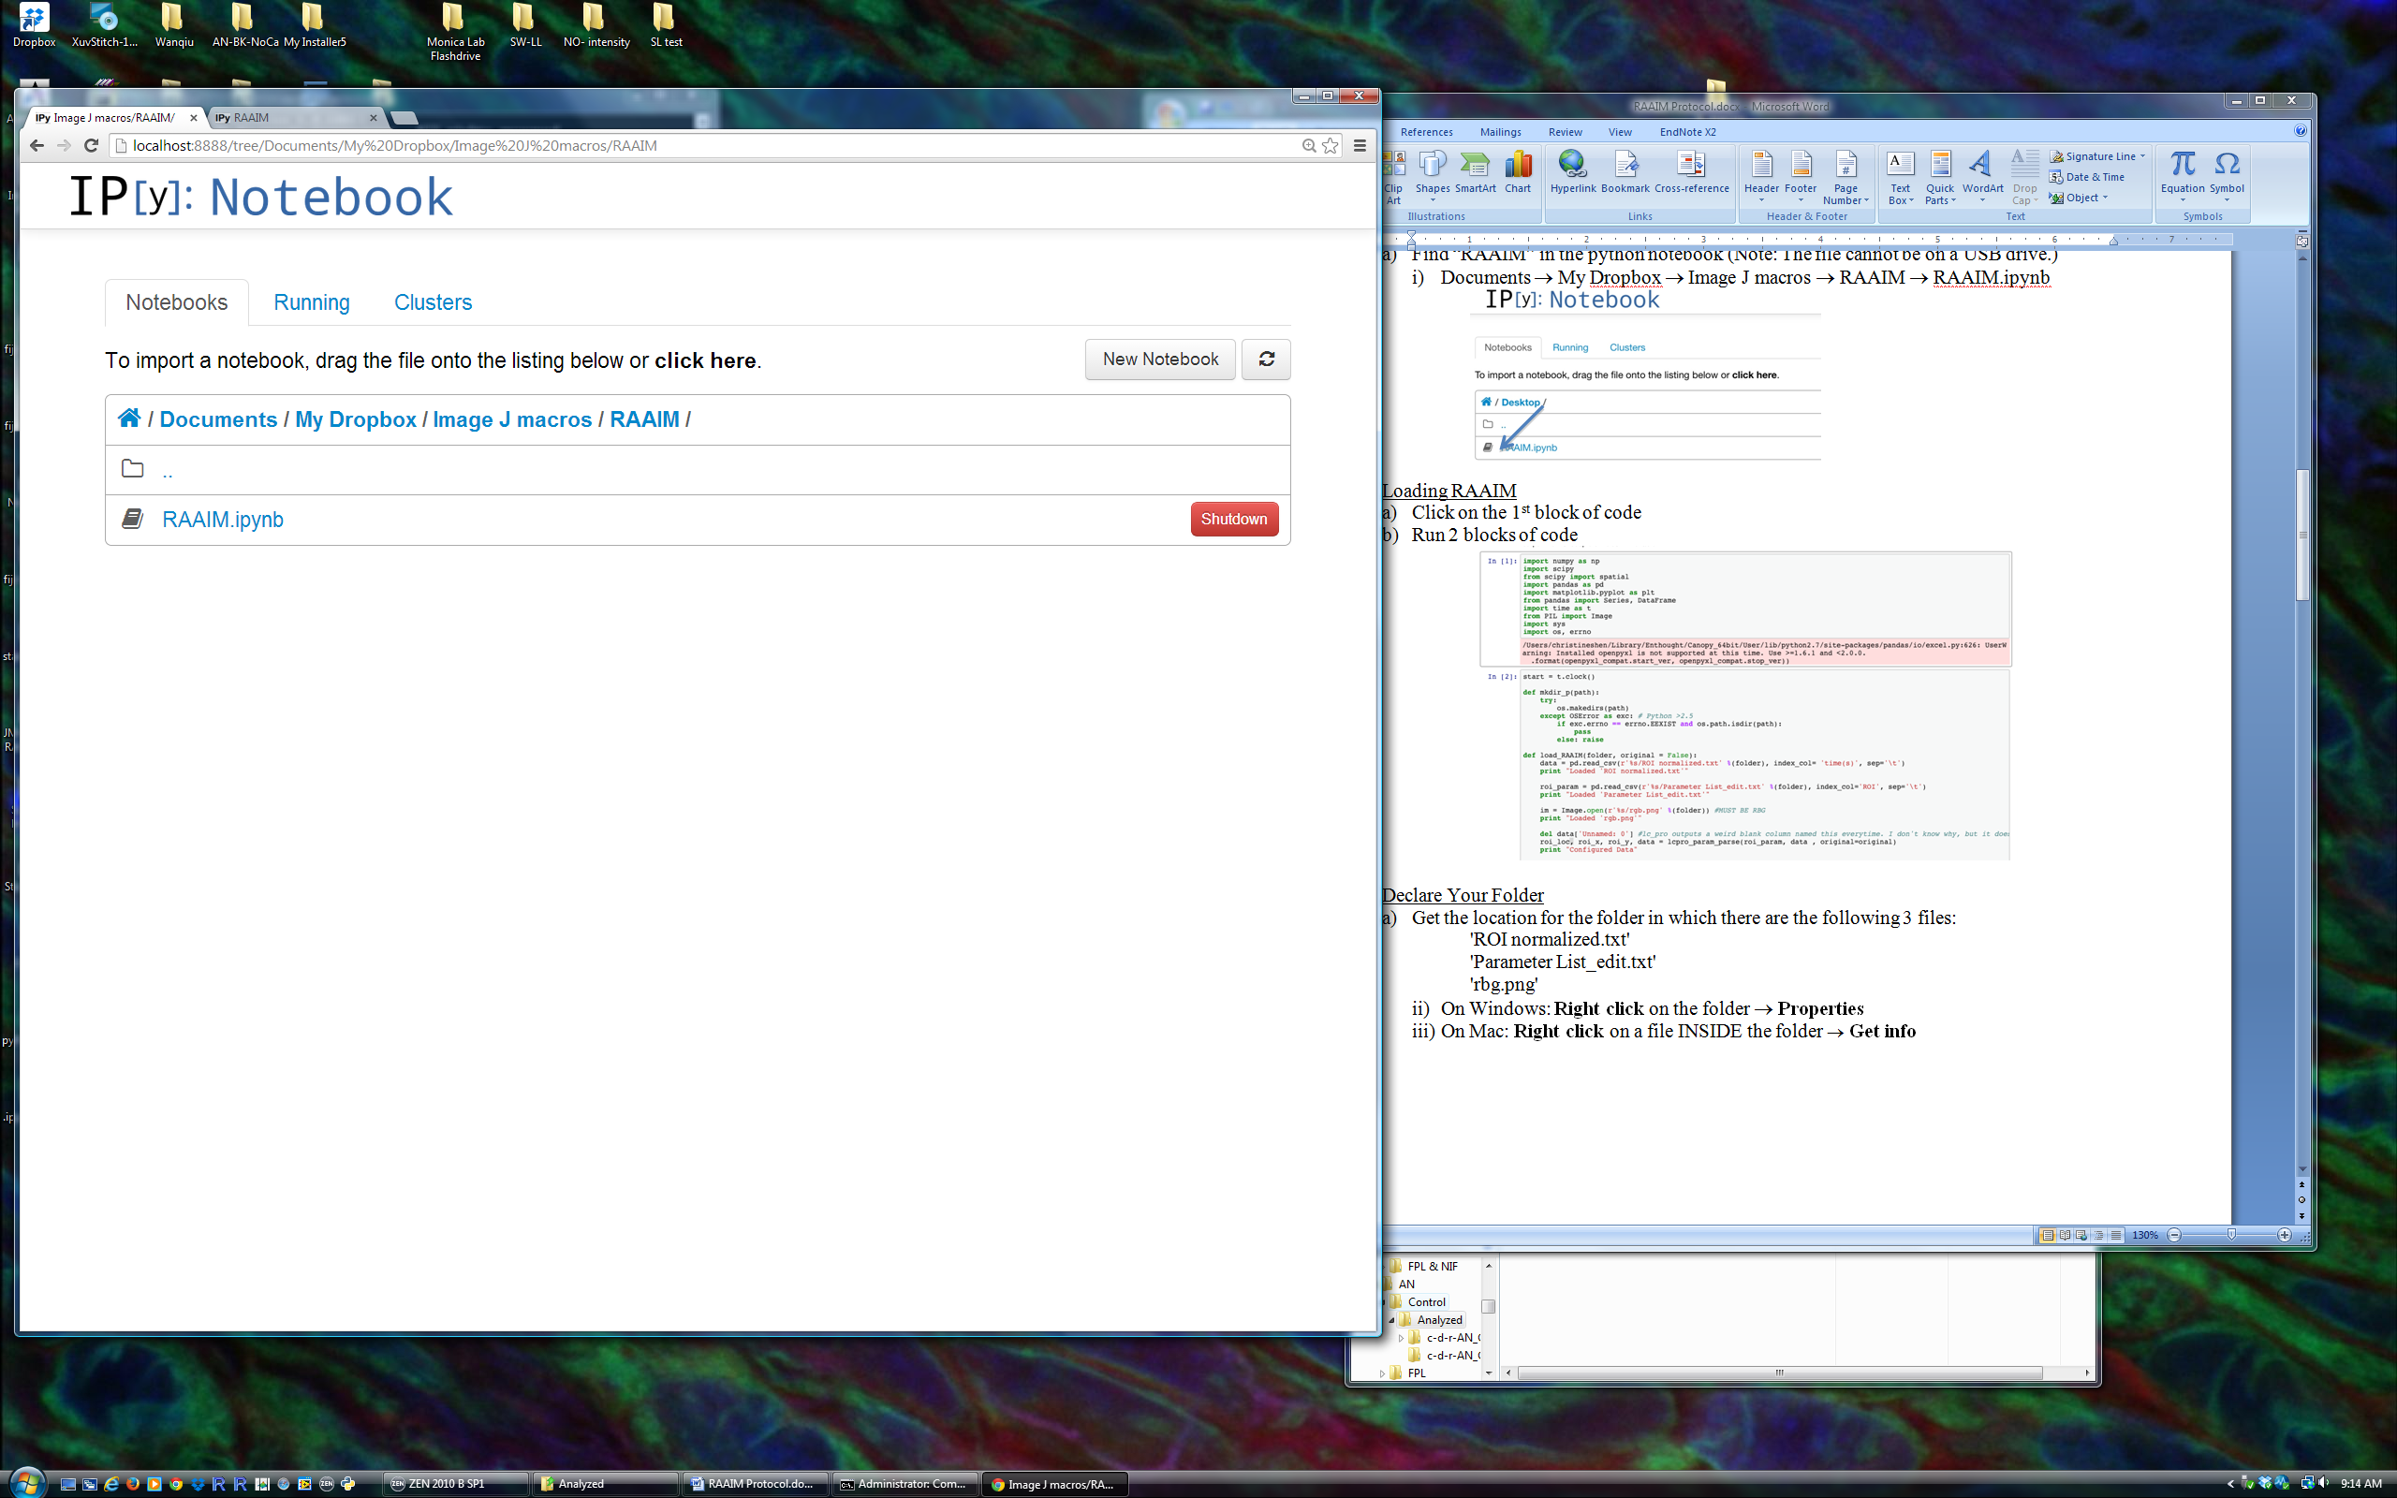

1. Loading RAAIM
   1. Click on the 1st block of code
   2. Run 1 block of code

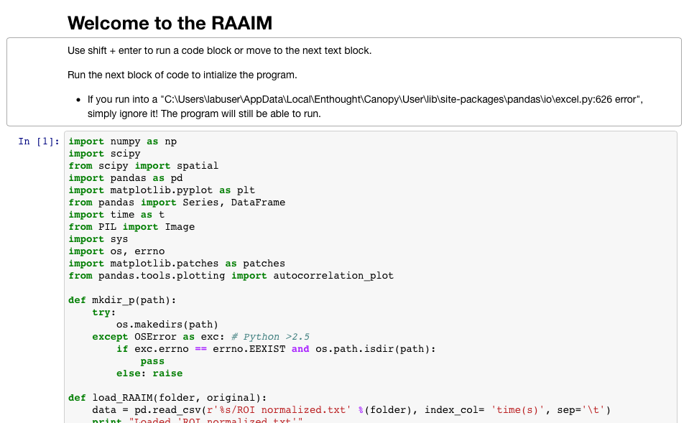

***I. Begin User Input***

1. IA. Declare Your Folder
   1. Get the location for the folder in which there are the following 3 files:

'ROI normalized.txt'

'Parameter List_edit.txt'

'rbg.png'

* + 1. On Windows: **Right click** on a file INSIDE the folder → **Properties**
    2. On Mac: **Right click** on a file INSIDE the folder → **Get info**

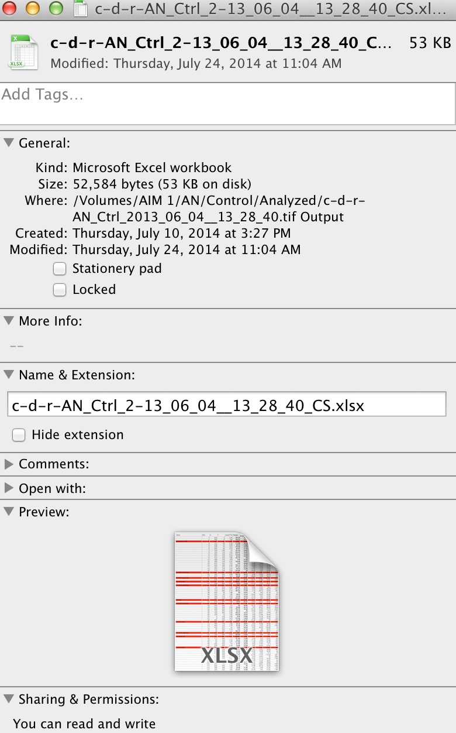

* + 1. Example of location: “/Volumes/AIM 1/AN/Control/Analyzed/c-d-r-AN_Ctrl_2013_06_04__13_28_40.tif Output”
    2. Copy and paste the location of the folder into the block of code, replacing the previous text INSIDE the quotation marks. Make sure the name of the file does not end in a slash (/).

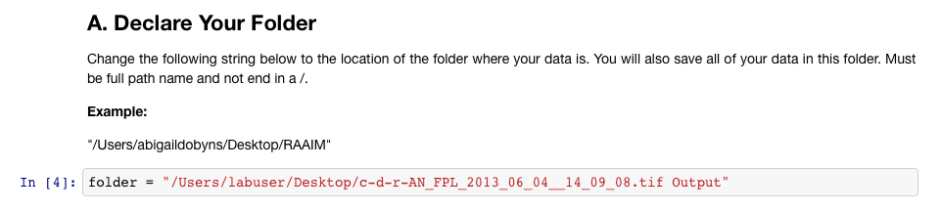

* 1. Run 1 block of code

1. IB. Load Data from the Folder
   1. Run 3 blocks of code

Note: An empty folder named **'plots'** should appear in the declared folder.

***II. Analysis***

*Note: In this section, the codes must run from start to finish.*

1. IIA. Cross Correlation Matrix (Friends)
   1. Set the correlation number in green.

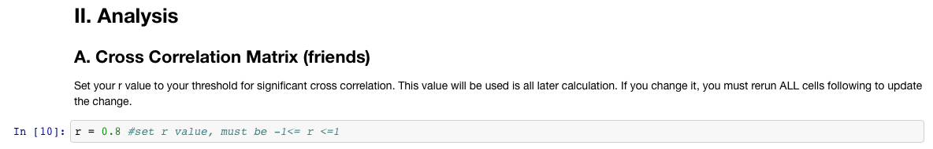

* 1. Run 4 blocks of code

Note: The files **'xcor.csv'** and **'xcor_summary.csv'** should appear in the declared folder.

1. IIB. Distance Matrix (Neighbors)
   1. Set the distance number in green.

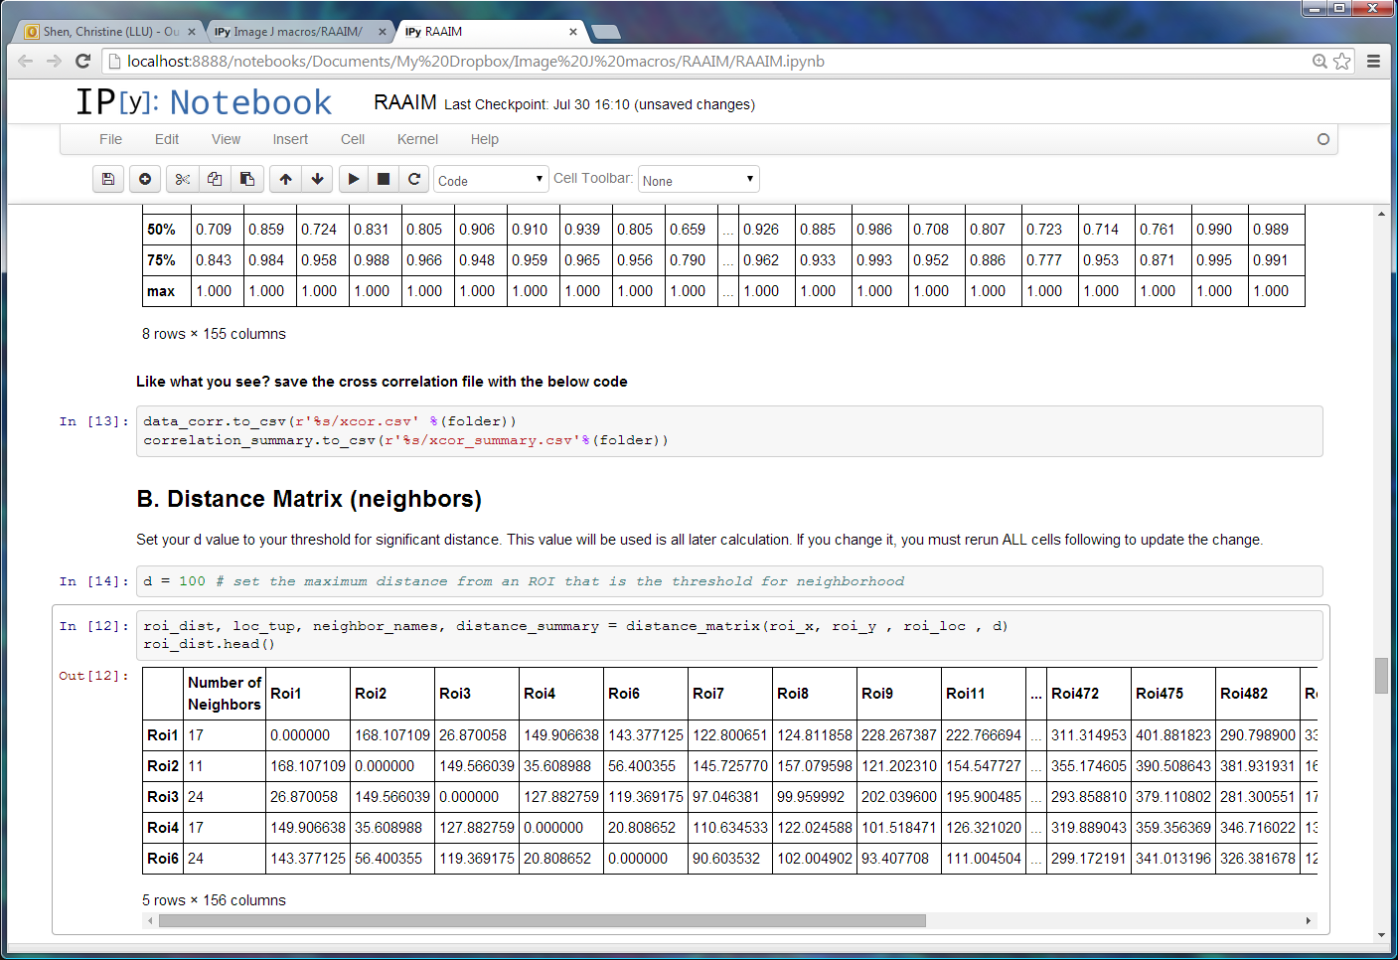

* 1. Run 4 blocks of code

Note: The files **friend_distances.csv'** and **dist_summary.csv'** should appear in the declared folder.

1. IIC. Friends in Terms of Neighbors
   1. Run 3 blocks of code

Note: The files **'friend_distances.csv'** and **'friend_distances_summary.csv'** should appear in the declared folder.

1. IID. Neighbors in Terms of Friends
   1. Run 3 blocks of code.

Note: The file **neighbor_correlation.csv'** and **'neighbor_correlation_summary.csv'** should appear in the declared folder.

***III. Resulting Plots***

*Note: In this section, each code can be run by itself.*

1. IIIA Part 1. 2D Plot - All ROIs with Name Calling
   1. Set the size of the yellow overlay circles as s= in green.

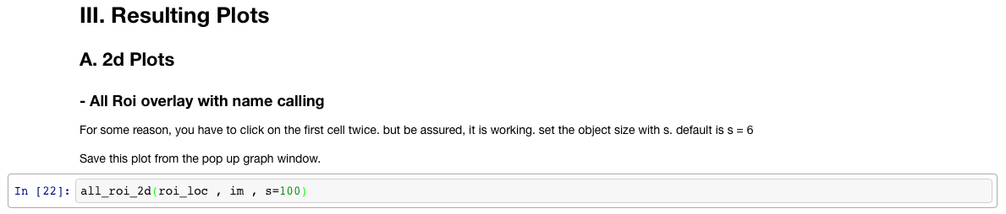

* 1. Run 1 block of code

Note: A graph window should appear

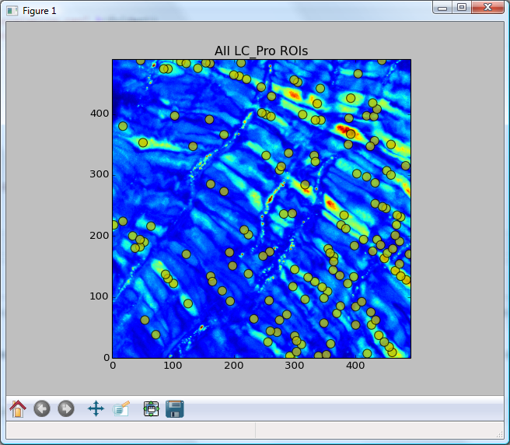

* 1. Save the plot into the declared folder with the name '
  2. **Name Calling**: Click on an ROI, and its number will appear in the notebook. The first one won't appear until you click the second one.

1. IIIA Part 2. 2D Plot - Select ROI & Friends

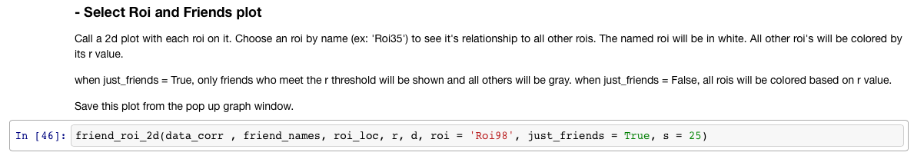

* 1. Set the ROI # in red

Note: ROIs are always named **'Roi#'** and must be in quotes.

* 1. Set the size of the yellow overlay circles with s= in green.
  2. Run 1 block of code

Note: A graph window should appear.

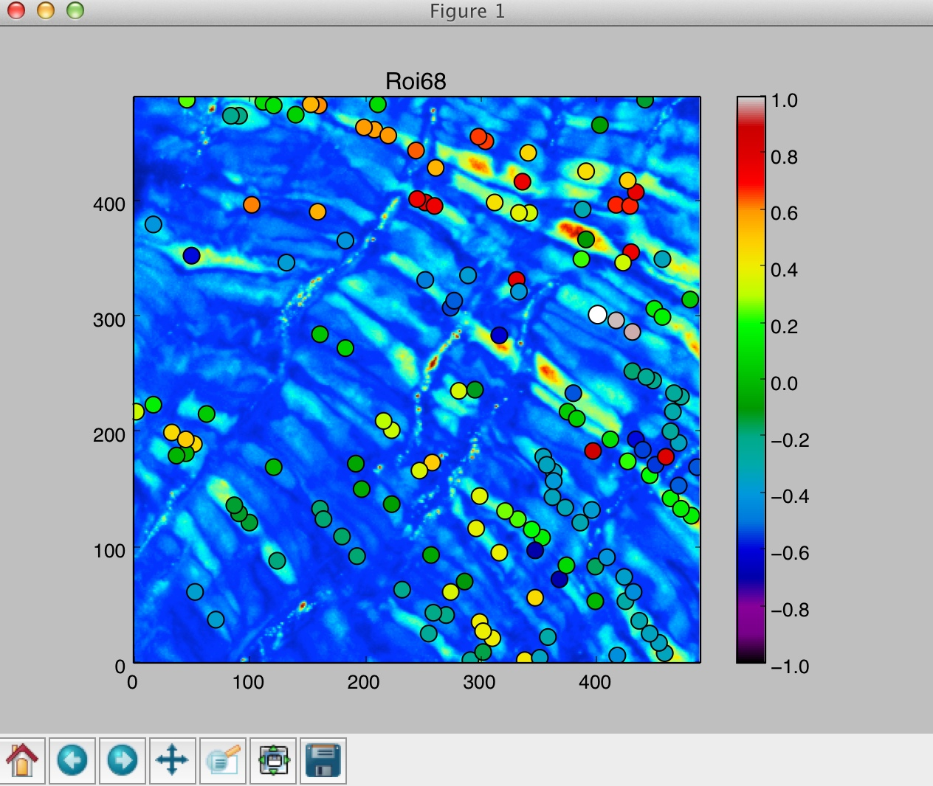

* 1. Save the plot into the declared folder with the name '

Note: To obtain a plot with a select ROI and the correlations of all other ROIs, change “just_friends = **False**” to “just_friends = **True**.” Save the plot into the declared folder with the name '

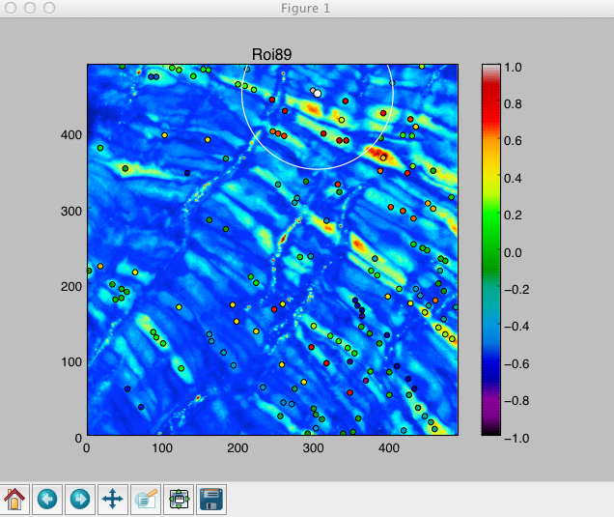

1. IIIB Part 1. Line Plots for all ROIs
   1. Run 1 block of code

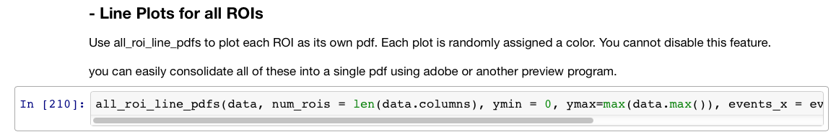

Note: All ROI line plot should appear in t folder **'plots'** in the declared folder.

1. IIIB Part 2. Line Plots for only one ROI
   1. Set the ROI # in red

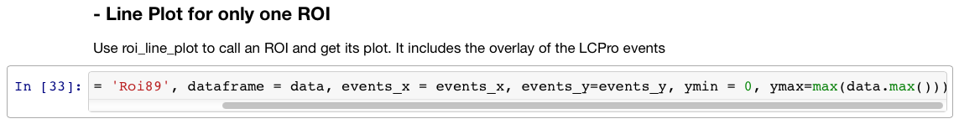

* 1. Run 1 block of code

Note: A graph window should appear

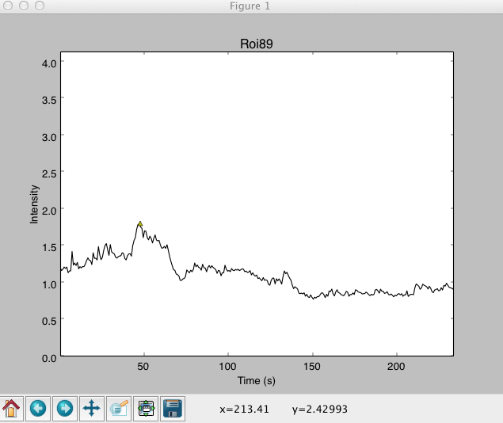

* 1. Save the plot into the declared folder with the name '

1. IIIB Part 3. Stacked Line Plot of an ROI and its Friends
   1. Set the ROI # in red

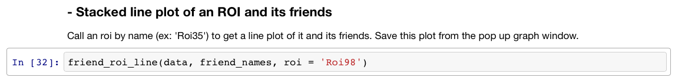

* 1. Run 1 block of code

Note: A graph window should appear

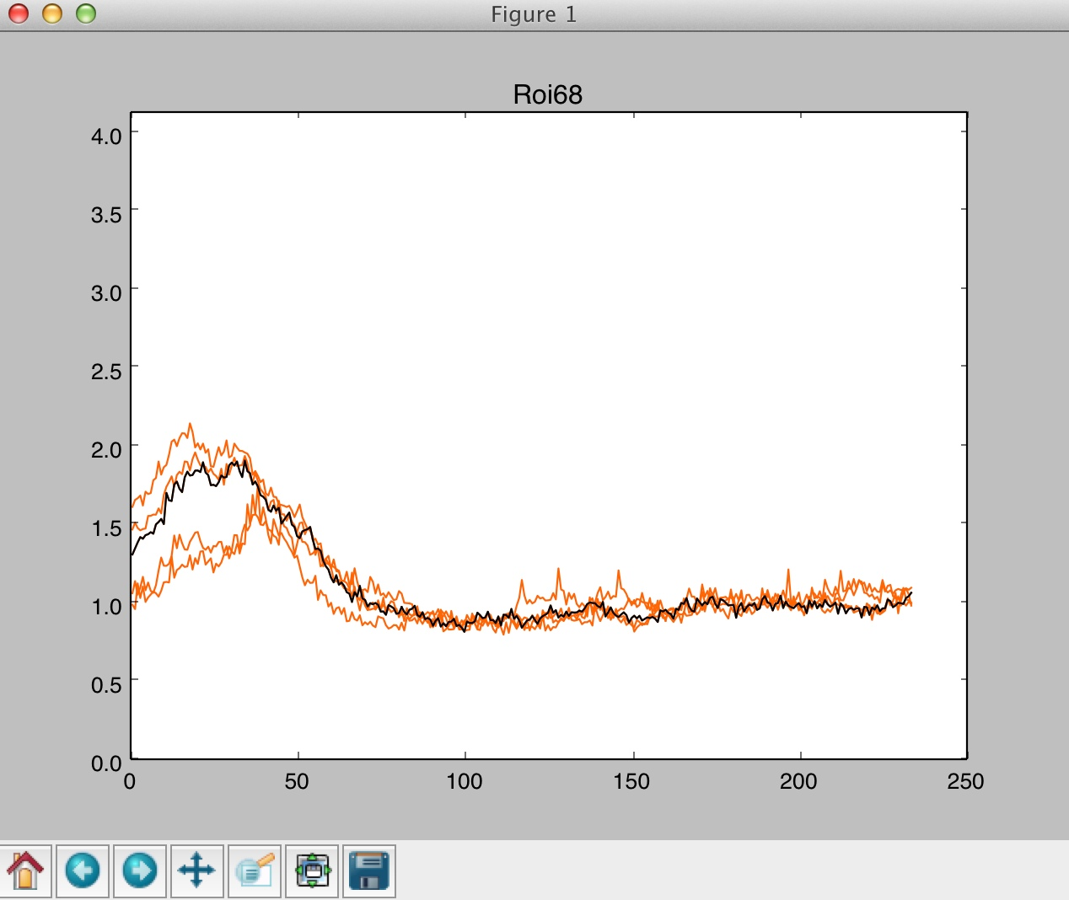

* 1. Save the plot into the declared folder with the name '

1. IIIB Part 4. Average Line Plot of ROI with Friends
   1. Set the ROI # in red

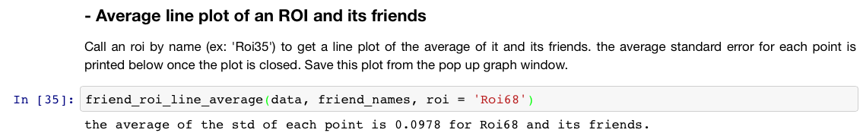

* 1. Run 1 block of code

Note: A graph window should appear

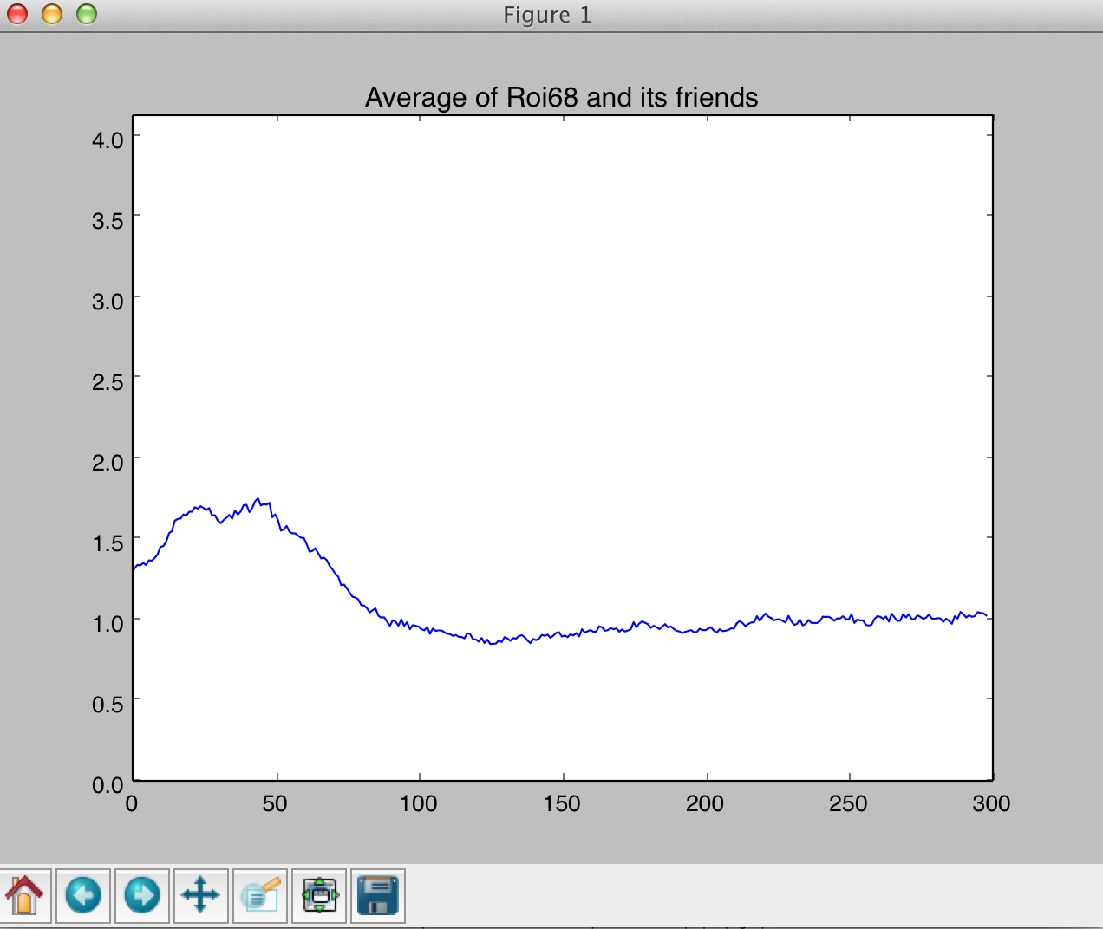

* 1. Save the plot into the declared folder with the name '

1. IIIB Part 5. Autocorrelation Plot
   1. Set the ROI # in red

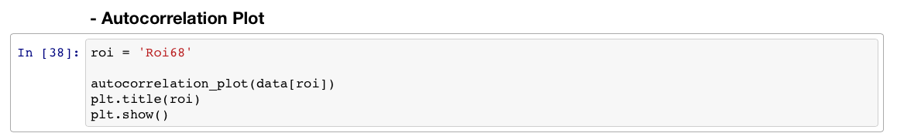

* 1. Run 1 block of code

Note: A graph window should appear

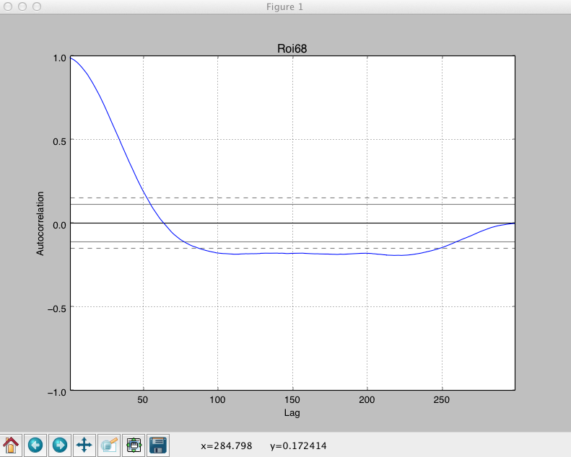

* 1. Save the plot into the declared folder with the name '

1. IIIC Box and Whisker Plots
   1. Run 1 block of code.

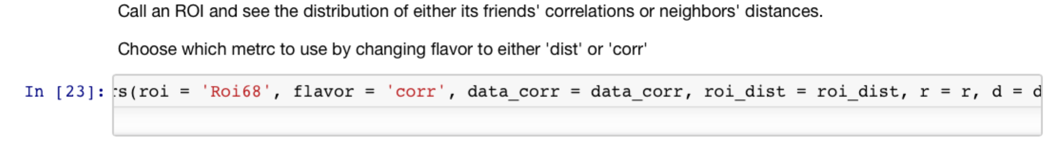

Note: A graph window should appear 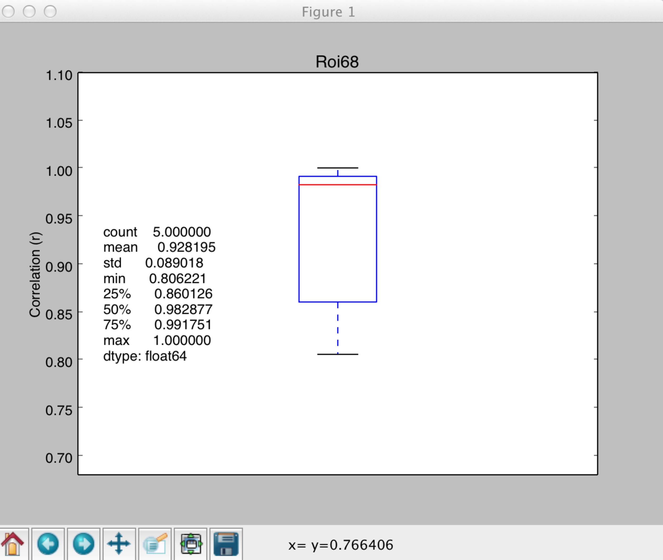

* 1. Save the plot into the declared folder with the name '

1. Randomizing the Dataset
   1. Run 2 blocks of code.

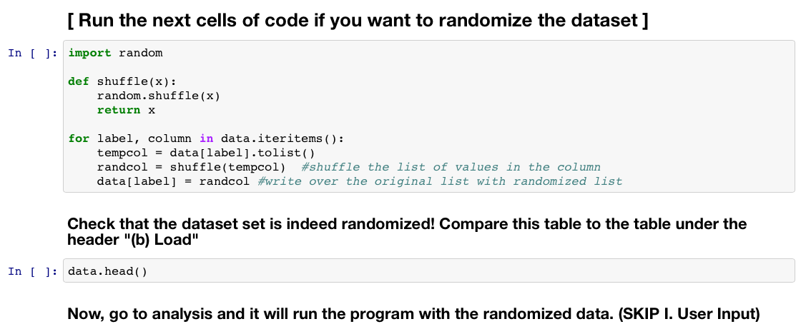

1. Closing Python
   1. In **Command Prompt** or **Terminal**, type **Control-C**
   2. Type **y**
   3. Close **Python Notebook**
   4. Close **Command Prompt** or **Terminal**

**Running RAAIM Rev2**

Note: All the analysis is compiled into one block of code.